Intermediate Algebra Lecture 8.4: An Introduction to Direct and Inverse Variation

Direct variation
If one thing goes up another thing goes up (work more get more money if work by the hour)

If y varies directly as x
y goes up when x goes up
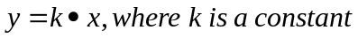

Example
Suppose y varies directly as x, if y is 24 when x is 8, find
k and set up the equation

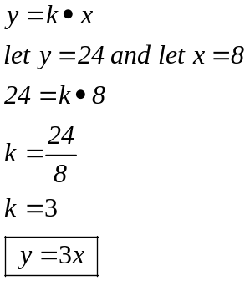

Example
Suppose y varies directly as x, if y is 20 when x is 15, find
k and set up the equation

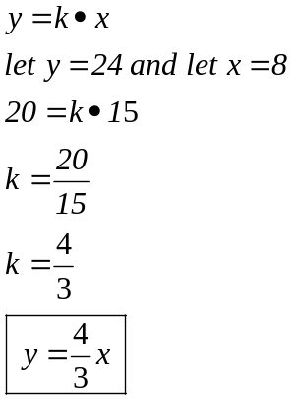

Example
The distance a spring stretches is directly proportional to the weight attached.
A 56 pound weight stretches the spring 8 inches.
How far will an 85 pound weight will stretch the spring

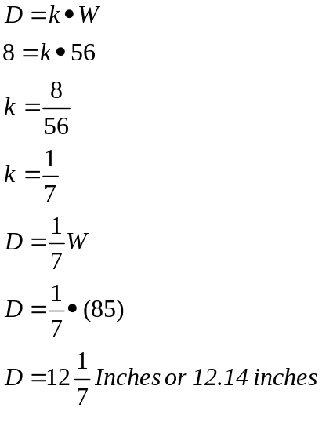
Inverse variation
If one thing goes up another thing goes down

If y varies inversely as x, y goes down as x goes up
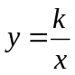

Example
Suppose y varies inversely as x, if y is 6 when x is 3, find
k and set up the equation

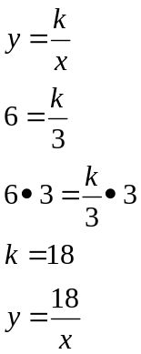

Example
The speed needed to travel a certain distance is inversely proportional to the time
The distance can be driven in 5 hours at a rate of 24 miles per hour.
How fast do you need to go to reach your destination in 4 hours.

